**Features of SalesVista**

This section highlights the key features integrated into the Gallery ErGo website, which were designed to provide users with a seamless, secure, and engaging online shopping experience. These features reflect the core functionalities required to meet the needs of both buyers and administrators. From user authentication and product browsing to manual payment verification and administrative controls, each feature was carefully developed to support the system's goals. By outlining these components, this section aims to demonstrate how the website operates to facilitate smooth transactions, maintain data security, and ensure efficient system management.

Figure 15

Dashboard Options

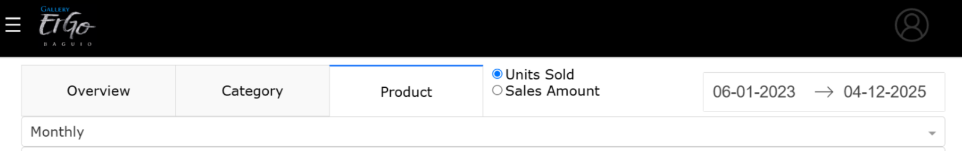

The dashboard menu remains visible across all its tabs, always allowing for easy navigation. It is divided into three distinct tabs, each displaying different sets of graphs and data. Users can customize the displayed information by selecting a specific date range using the date range picker located at the top right corner. Additionally, the dashboard offers filtering options that allow users to toggle between viewing data based on either unit sold or total sales amount, using radio buttons positioned to the left of the date picker. To further refine the data presentation, users can group the results by day, week, or month through a dropdown selection.

Figure 16

Dashboard Overview

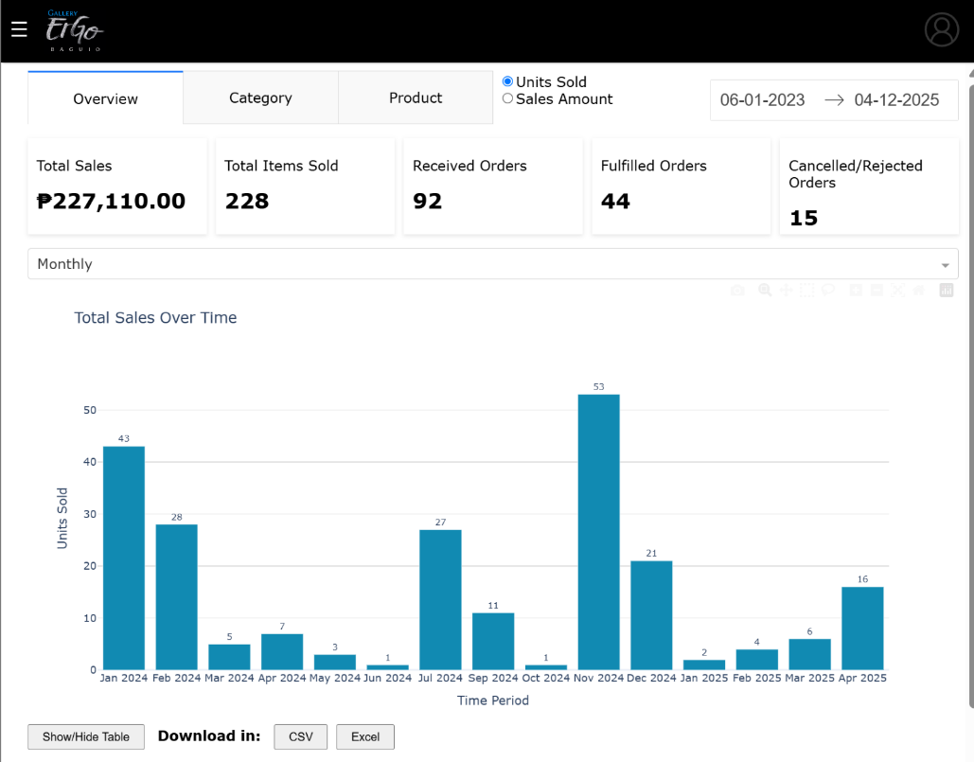

The Overview tab provides a summarized view of key sales and order metrics, including total sales, total items sold, received orders, fulfilled orders, and cancelled or rejected orders. It features a grouped bar chart titled Total Sales Over Time, accompanied by a table that users can both view and download in .csv or .xlsx format. In addition, the tab includes two more visualizations: a horizontal bar chart displaying the Top 10 Products, and a pie chart representing Sales Performance by Category.

Figure 17

Dashboard Category

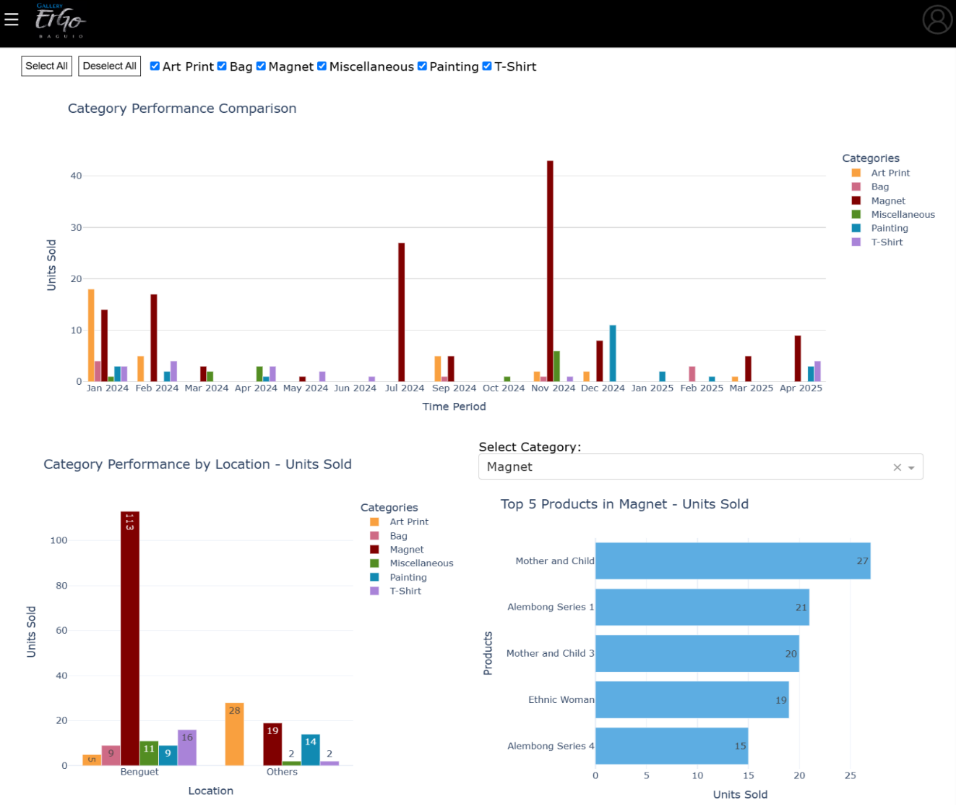

The Category tab offers a detailed visual breakdown of product performance across various categories. It includes three interactive charts: the Category Performance Comparison grouped bar chart, which highlights the overall performance of each category; the Category Performance by Location grouped bar chart, which displays how each category performs across different delivery areas; and the Top 5 Products per Category horizontal bar chart, which showcases the best-selling items within each product category. These visualizations help administrators and sellers identify trends, evaluate category strengths, and make data-driven decisions to improve inventory and marketing strategies.

Figure 18

Dashboard Products

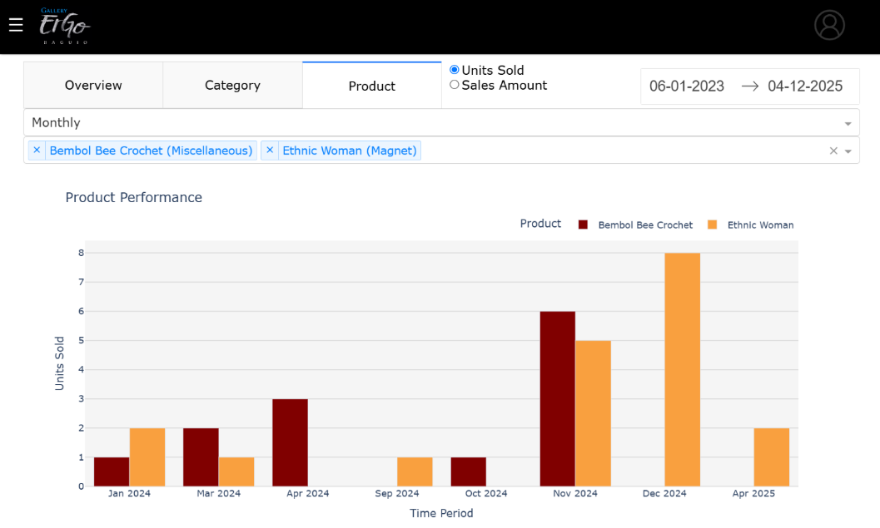

The Products tab enables administrators to search for and compare the performance of up to five individual products simultaneously. This is done by using the input field located beneath the time aggregation dropdown menu, where product names or categories can be entered for quick filtering. If a selected product does not appear in the resulting graph, it indicates that no sales have been recorded for that item within the specified timeframe. This feature helps administrators monitor product performance and make informed decisions regarding inventory and sales strategies.

Figure 19



Figure 20

Manage Orders

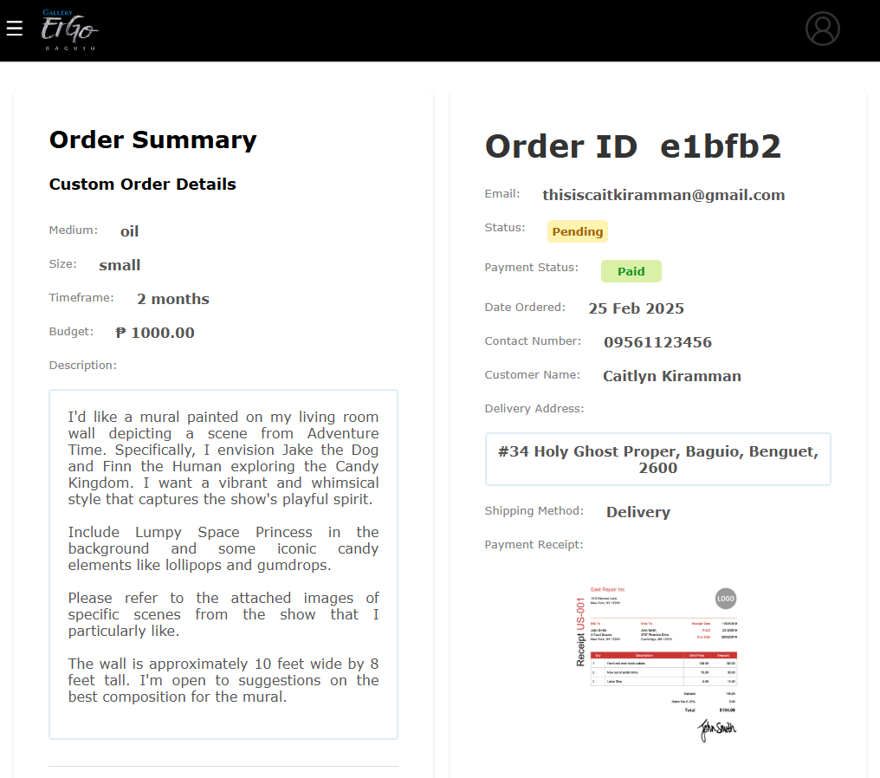

As shown in Figure 20, the Manage Orders feature provides the seller with access to all incoming customer orders. This includes information such as order ID, product details, quantity, buyer name, and shipping status. Admins can update the status of each order (e.g., processing, shipping, delivered), helping ensure timely fulfillment and customer satisfaction.

Figure 21

Downloadable Sales Table

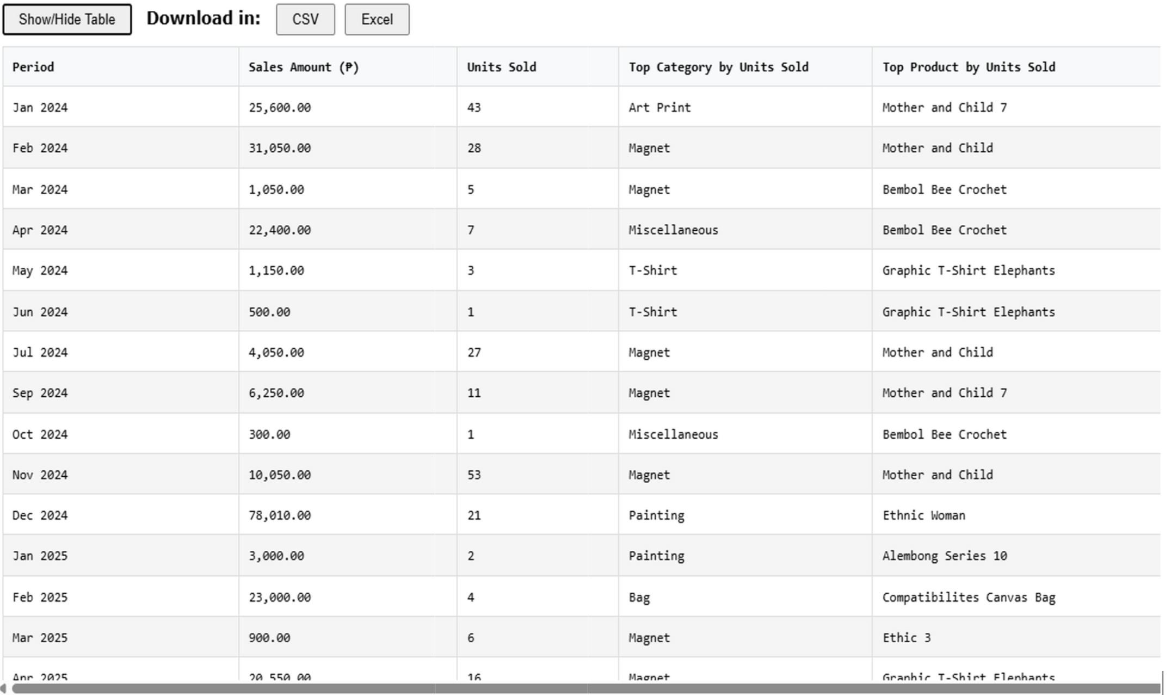

Figure 21 presents the Downloadable Sales Table feature in the Dashboard App. This functionality provides the admin with a detailed sales record that can be exported as a CSV or Excel file. The table displays comprehensive monthly sales data including sales amounts, units sold, top-selling categories, and best-performing products for each period. The downloadable table allows for external analysis, report generation, and record-keeping. It supports administrative tasks such as financial tracking, sales performance reviews, and inventory planning based on real-time and historical data.

Figure 22

Customer Landing Page

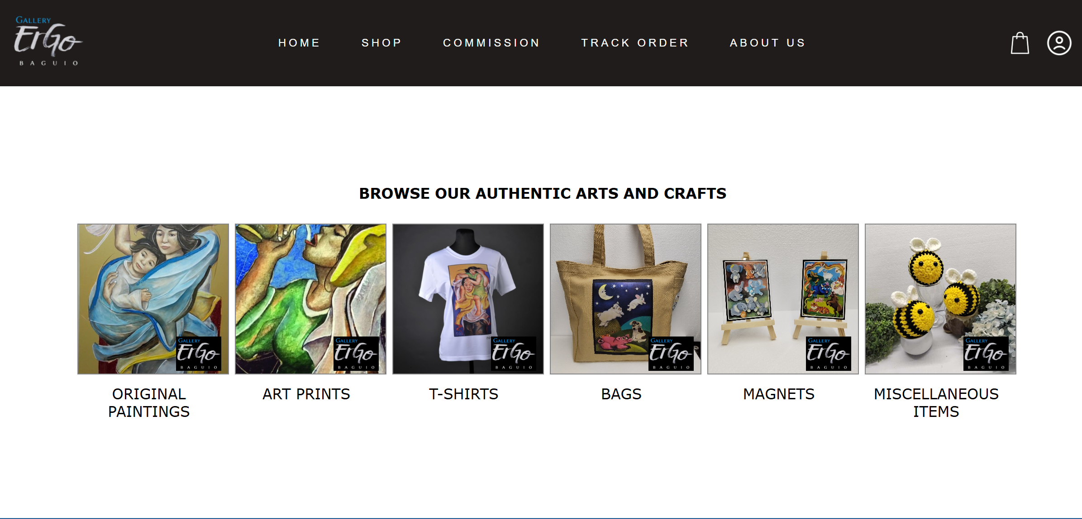 The Customer Landing Page serves as the welcoming interface for users visiting the Gallery ErGo website. It is designed to provide a clean, visually engaging introduction to the platform while highlighting featured products, categories, and ongoing promotions. The landing page includes an intuitive navigation bar, allowing users to easily browse collections, search for specific items, and access their shopping cart or account settings. Whether the user is a first-time guest or a returning customer, the landing page ensures a smooth and inviting entry point to the online shopping experience. It is optimized for both desktop and mobile devices, ensuring accessibility and responsiveness across all screen sizes.

Figure 23

Shop Page

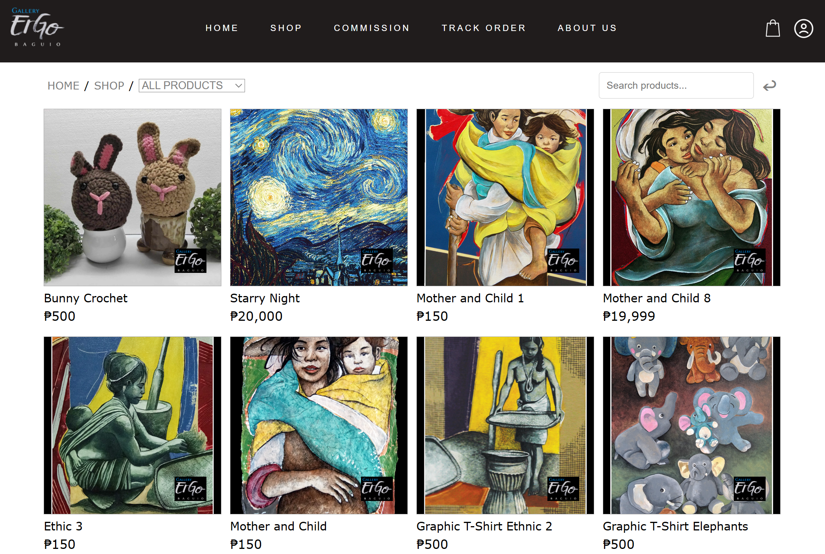

On the Shop page, customers can easily browse available products either by selecting a category from the menu located at the upper left corner or by using the search bar positioned at the upper right. This allows for quick filtering based on preferences or specific product names. Once a product is found, customers can click on the item to view detailed information, including images, descriptions, price, and availability. This streamlined browsing experience helps users navigate the catalog efficiently and make informed purchasing decisions.

Figure 24

Product Details

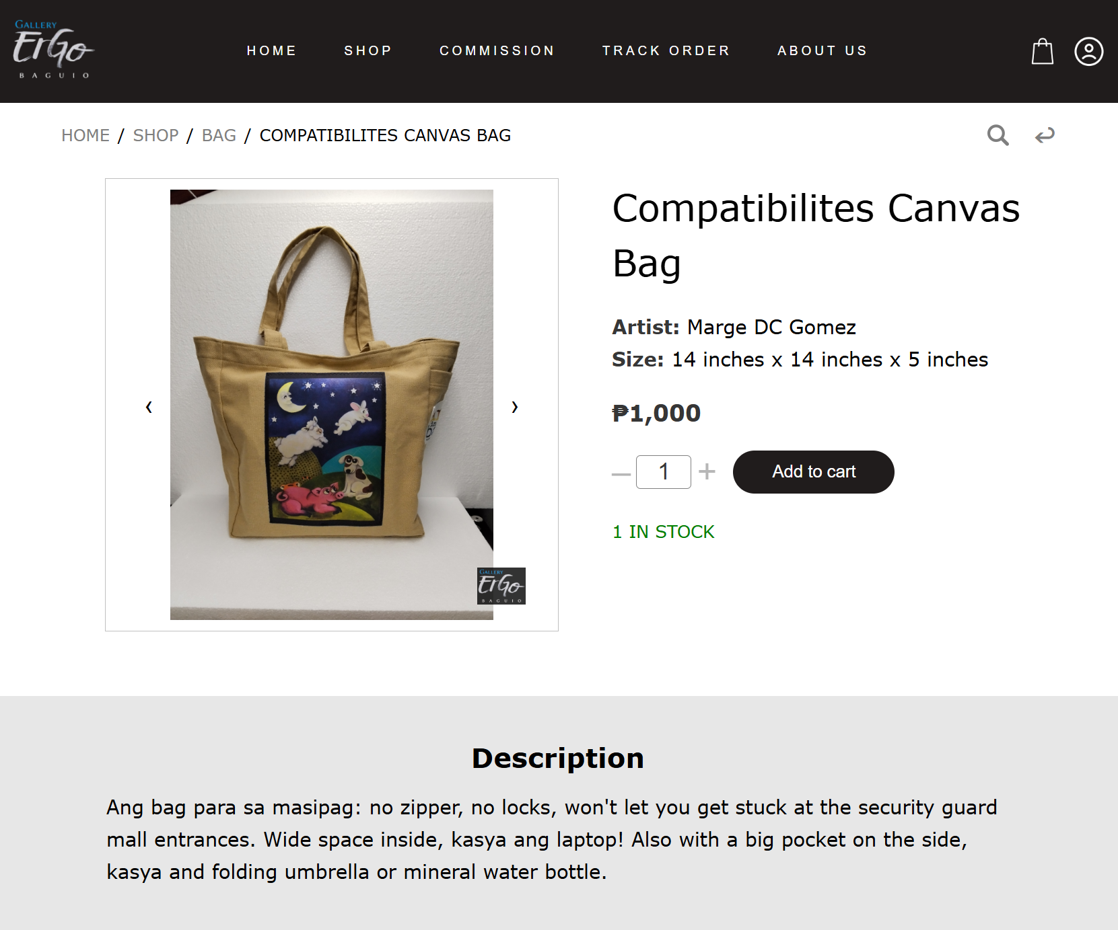 Customers can easily add products to their shopping cart by clicking the "Add to Cart" button available on each product's detail page. Before confirming the addition, users have the option to adjust the quantity based on the available stock using the increment and decrement controls. This feature ensures flexibility and allows customers to manage their desired purchases efficiently while keeping track of stock availability in real time.

Figure 25

Recommended Products

 A maximum of five related products are displayed in this section, selected based on similarities in either category or product name. This feature helps customers discover additional items that align with their interests, encouraging further browsing and potential purchases. It enhances the shopping experience by offering relevant suggestions tailored to the product currently being viewed.

Figure 26

Cart

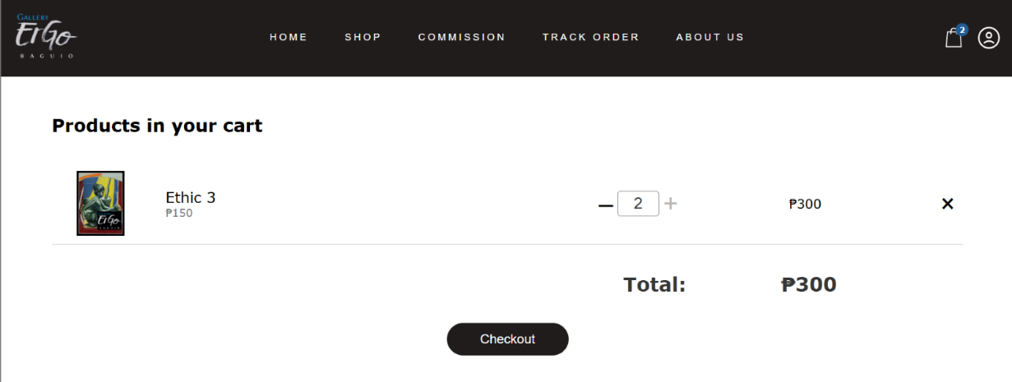

Customers have full control over the items in their cart. They can update the quantity of each product using the provided controls or remove items entirely if needed. Once the cart is finalized, clicking the "Checkout" button allows the customer to proceed with placing their order. This feature ensures a smooth and flexible shopping experience, giving users the ability to review and adjust their selections before completing the transaction.

Figure 27

Checkout

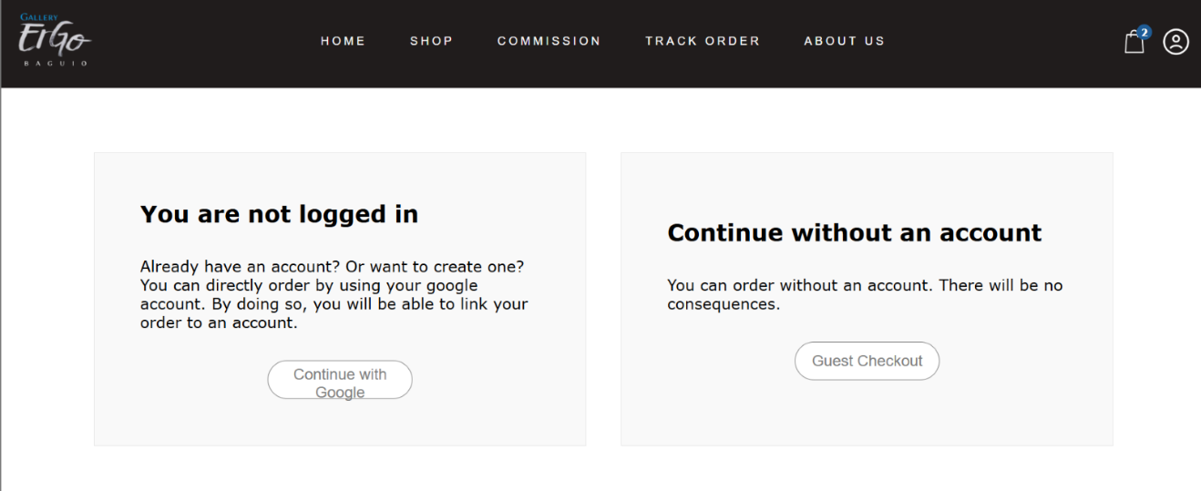 Upon proceeding to checkout, customers are given the option to place an order either by logging in with their Google account or by continuing as a guest. Selecting "Continue with Google" redirects the user to the Google login page for a quick and secure sign-in process. Alternatively, customers can choose "Guest Checkout" to complete their purchase without creating or logging into an account. This flexibility allows for a convenient and user-friendly shopping experience, accommodating both new and returning users.

Figure 28

Login

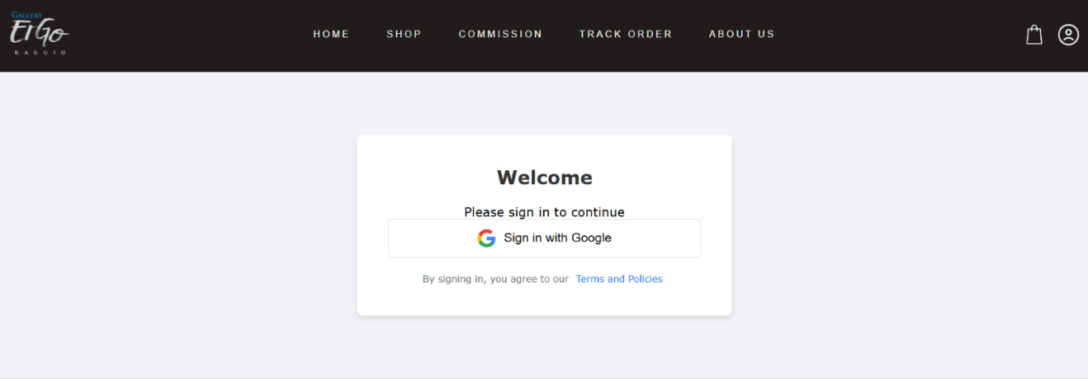  
 Clicking on “Sign in with Google” will redirect the customer to Google’s login page, where they can securely sign in to the website using their Google account credentials. This provides a quick and seamless authentication process, eliminating the need for manual account creation. By leveraging Google’s secure authentication protocols, the website ensures user data privacy and reduces the risk of unauthorized access. Additionally, this integration allows customers to access their personalized settings and preferences without needing to remember multiple passwords. The process enhances the overall user experience, making it more convenient and secure.

Figure 29

Checkout Form

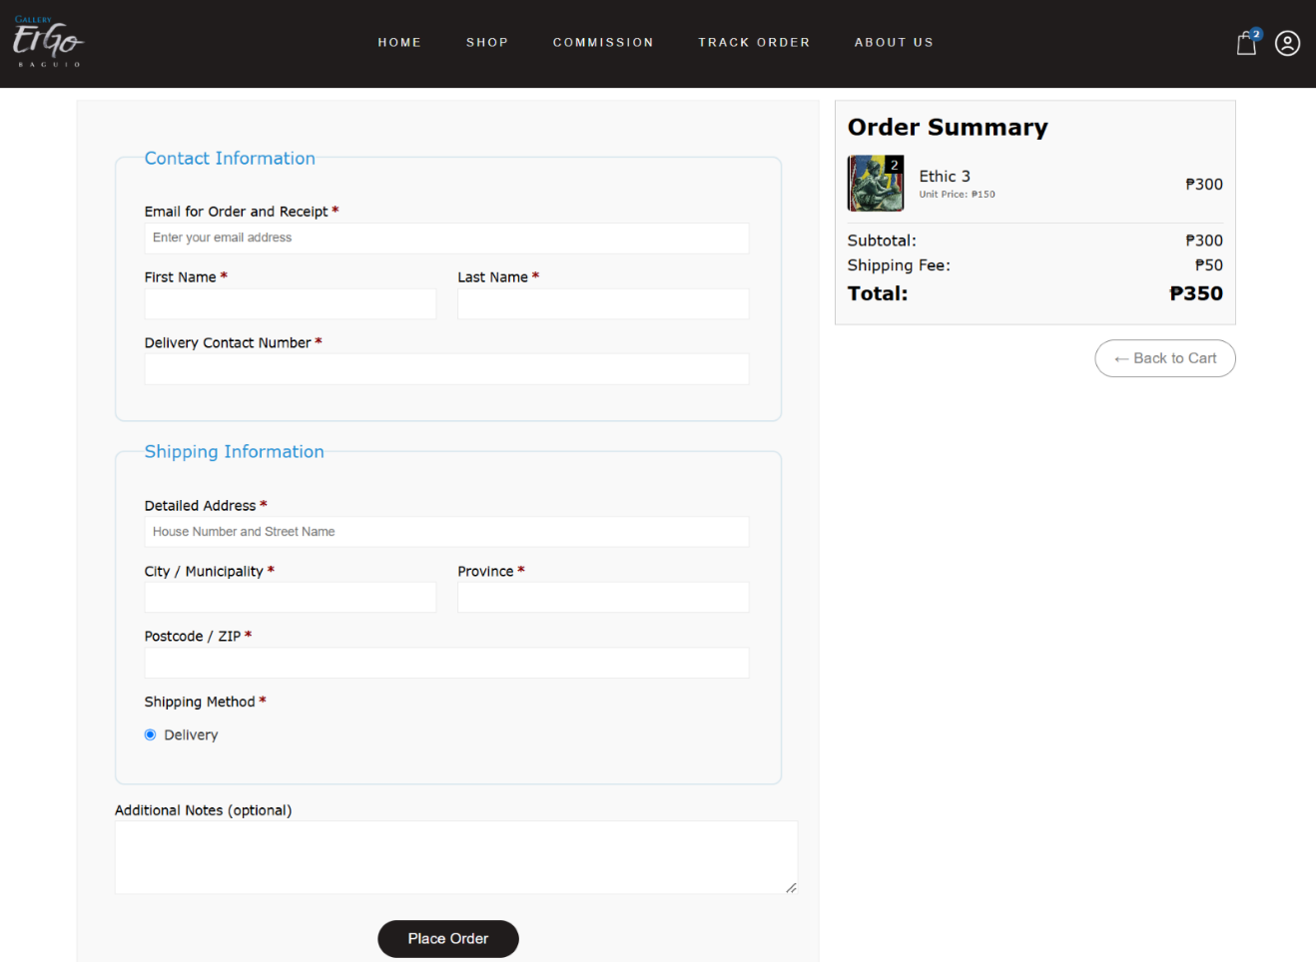  
 Before completing an order, customers are required to provide essential contact and shipping details. This includes their full name, contact number, and delivery address to ensure accurate order processing and successful delivery. These details are also used to verify the identity of the customer and prevent fraudulent activities. Additionally, the system may offer an option to save this information for future orders, streamlining the checkout process for returning customer.

Figure 30

Commission

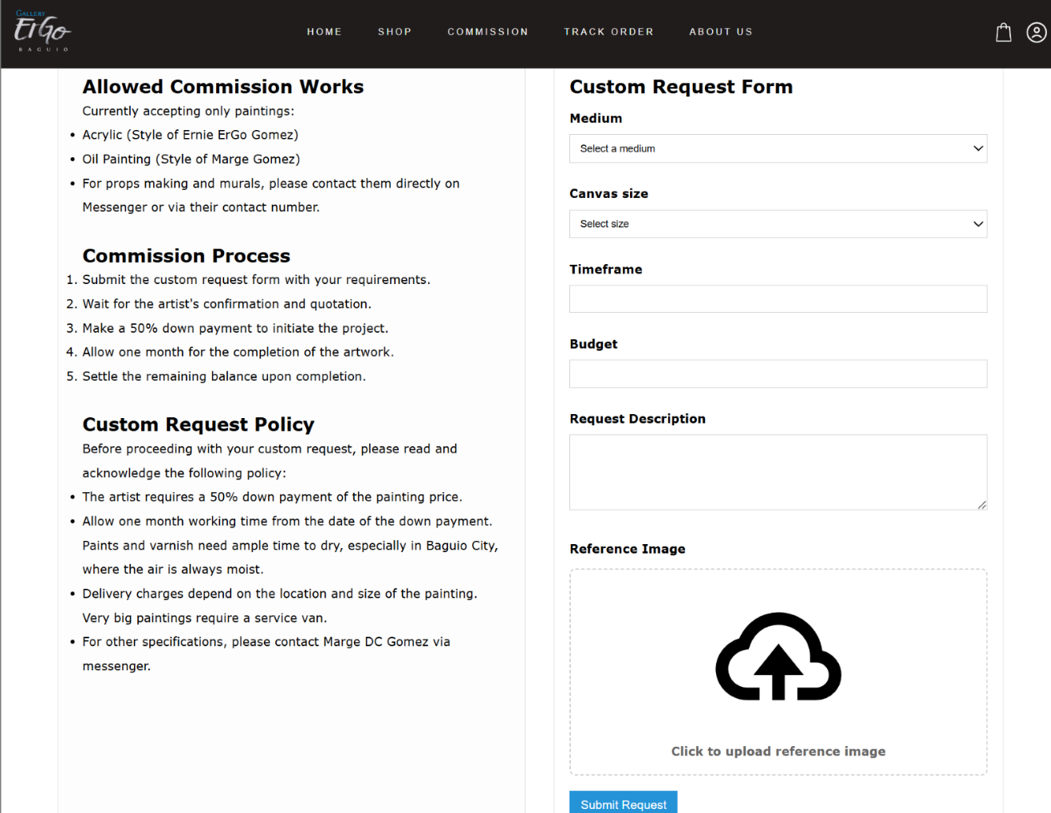 To request a custom painting from the artist, customers must first confirm that they have read and understood the commission policy and process by clicking the “I Acknowledge” button. Once acknowledged, the custom request form will appear, allowing the customer to enter specific details about their desired artwork. After completing the form, the customer can click “Submit Request” to send their commission request to the artist for review and confirmation.

Figure 31

Art Protection Feature

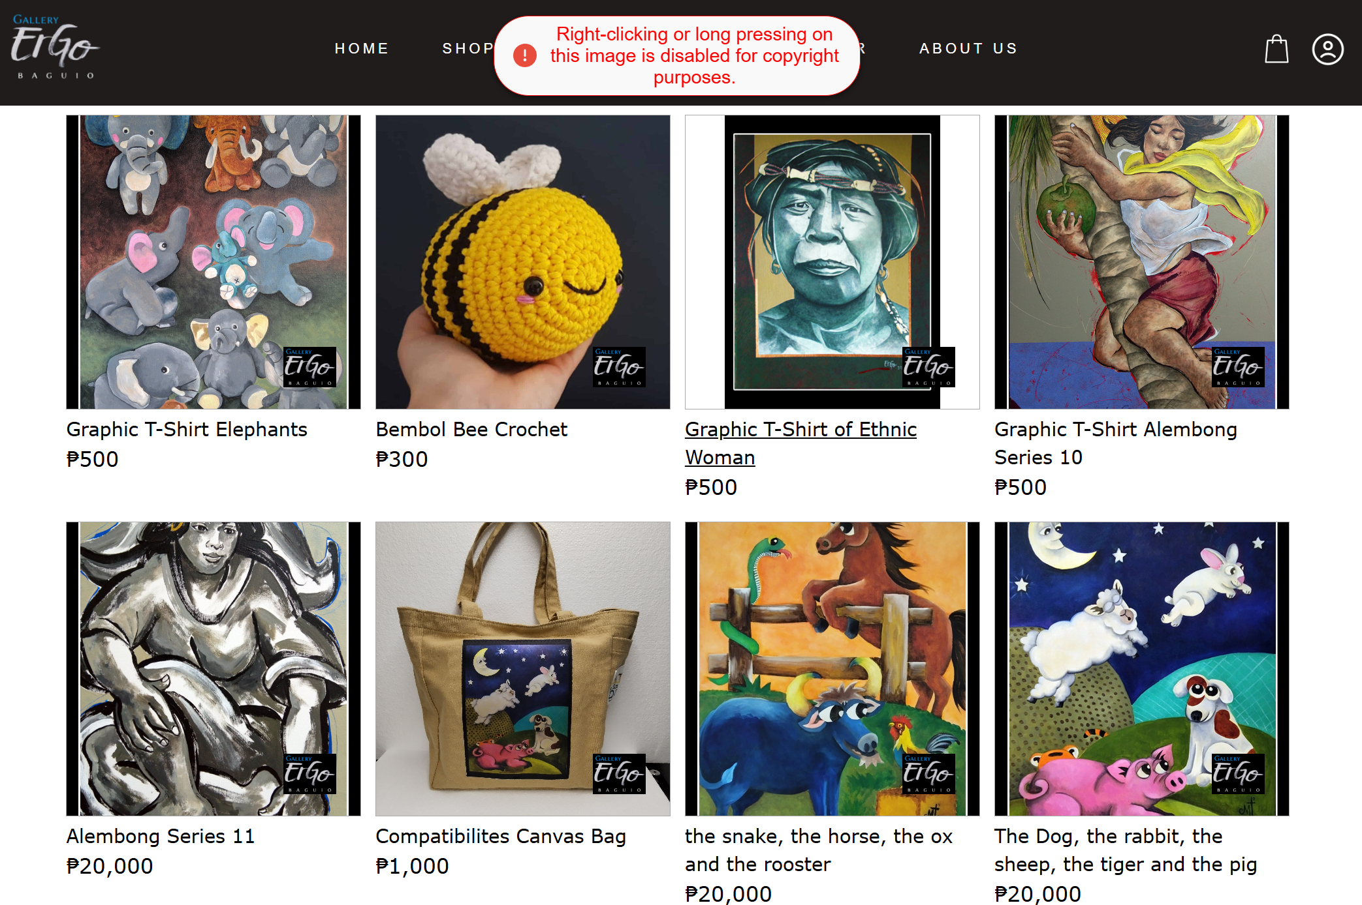

Figure 31 shows that artworks displayed on the platform are protected through embedded watermarks and by disabling options for downloads or prints. These protection mechanisms prevent unauthorized use or reproduction of the artists’ original work, ensuring their intellectual property remains secure.